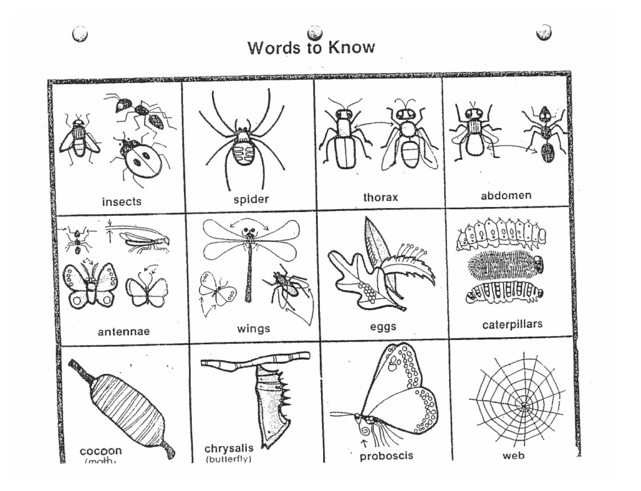

Small Crawling & Flying Animals
Vocabulary

Adaptations – physical characteristics or behaviour, which helps a plant or animal live, successfully where it does.

Abdomen – “The abdomen is one of the three main body segments of insects.

Camouflage – body colour or markings that help an animal hide from its predators (enemies).

Chrysalis – the protective covering around the pupae of butterflies.

Cocoon - the protective covering around the pupae of some insects - particularly moths.

Decomposer - any plant or animal that feeds on and breaks down dead plants or animals into smaller pieces that will become part of the soil (earthworms, centipede, fly, slug).

Exoskeleton – a hard outer skin that protects soft insides.

Habitat – the natural place where a plant or animal grows and lives.

Insect – has 3 distinct body parts (head, thorax, abdomen), 6 legs (3pairs), 1 pair of antennae and an external skeleton (exoskeleton).

Invertebrate – any animal that does not have a spinal column (backbone).

Life Cycle/Metamorphosis – the change from young to adult, usually four stages (egg, larva, pupa, adult)

Proboscis – a projection or elongated appendage at the front of the face. In vertebrates (animals with a spinal column or spine), the term is used to describe an elongated nose or snout (e.g., aardvark or elephant). In invertebrates, the term usually refers to tubular mouthparts used for feeding and sucking.

Pupa – “the part of the process of becoming an adult for some insects: butterflies, moths, beetles, flies, and bees. The pupal stage comes after being a larva; the next stage is adulthood.” The pupa in stage in butterflies is the chrysalis. In moths, it is the cocoon.

Physical Characteristic – a quality or feature (thing) on a body.

Predator – animal that hunts other animals for food.

Thorax – the second or middle part of an insect's body.

