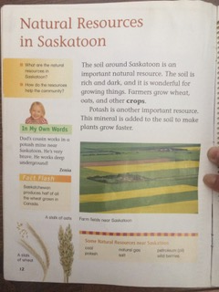

Bottom box (page 12) - Some Natural Resources near Saskatoon: coal, potash, natural gas, salt, petroleum (oil), wild berries.
Fact Flash: Saskatchewan produces half of all the wheat grown in Canada
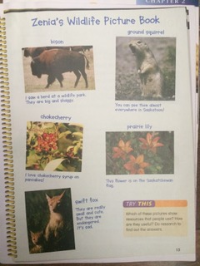
bison - I saw a herd at a wildlife park. They are big and shaggy.
ground squirrel – You can see them almost everywhere in Saskatoon.
Chokeberry – I love chokecherry syrup on pancakes!
Prairie lily – This flower is on the Saskatchewan flag
Swift fox- They are really small and cute. But they are endangered. It’s sad.

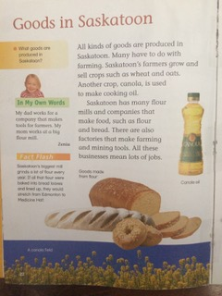
Fact Flash from page 22 – Goods in Saskatoon: Saskatoon’s biggest mill grinds a lot of flour every year. If all that flour were baked into bread loaves and lined up, they would stretch from Edmonton to Medicine Hat.

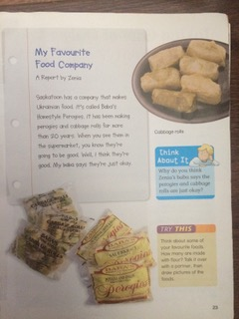
Think About It (page 23): Why do you think Zenia’s baba says the perogies and cabbage rolls are just okay?
Try This: Think about some of your favourite foods. How many are made with flour> Talk it over with a partner, then draw pictures of the foods.

